**10563321**

**ICT1521**

**ASSIGNMENT 3**

**Question 1**

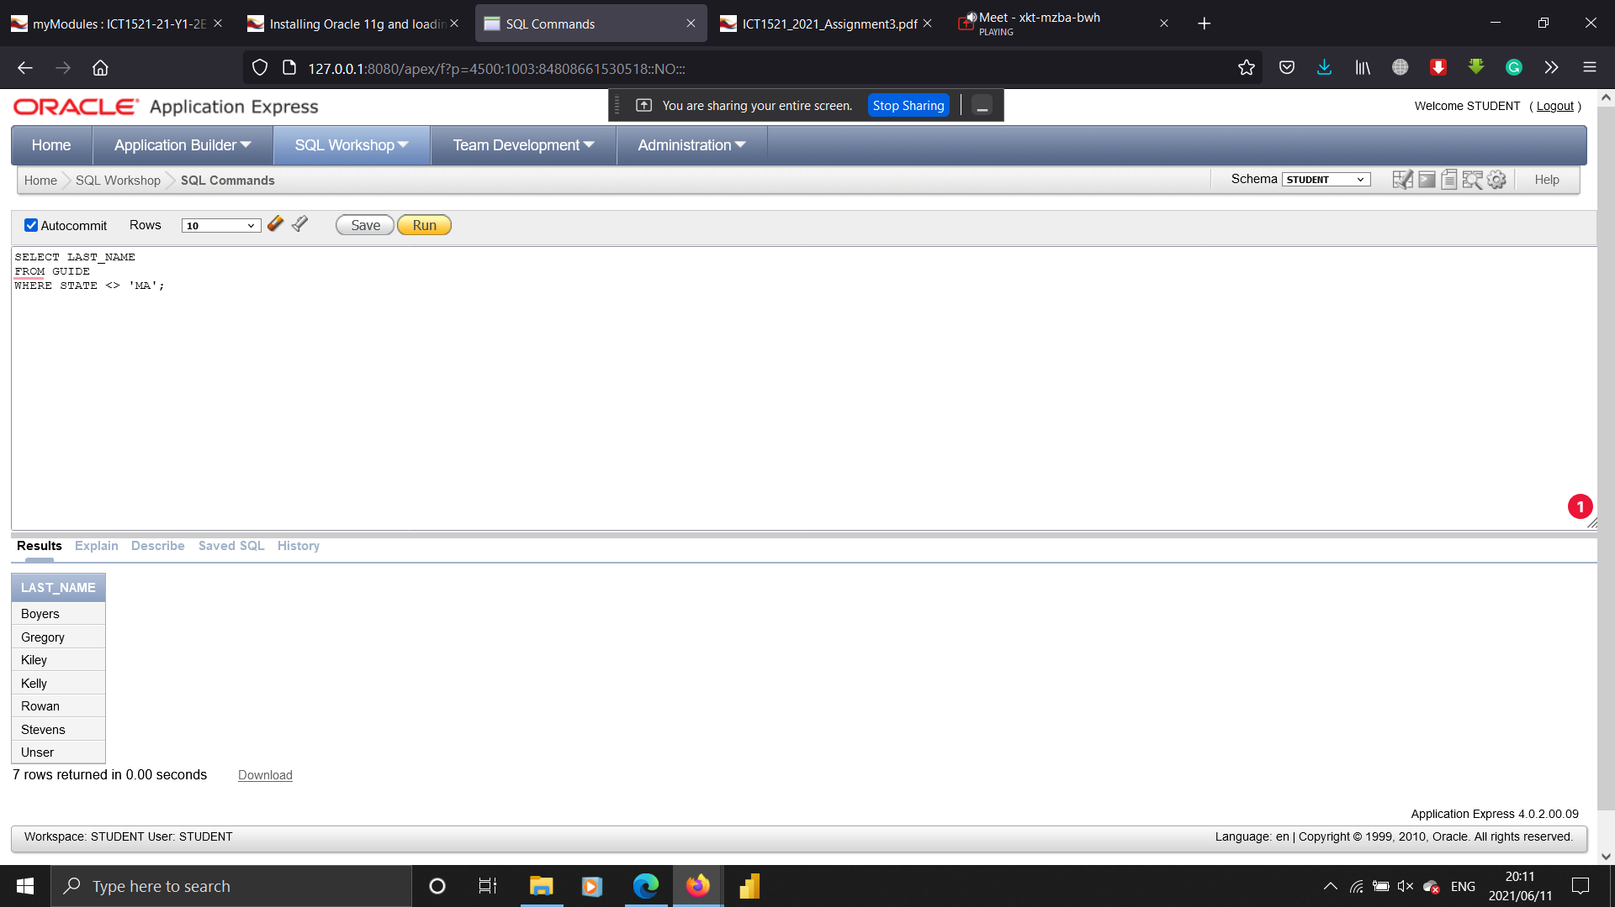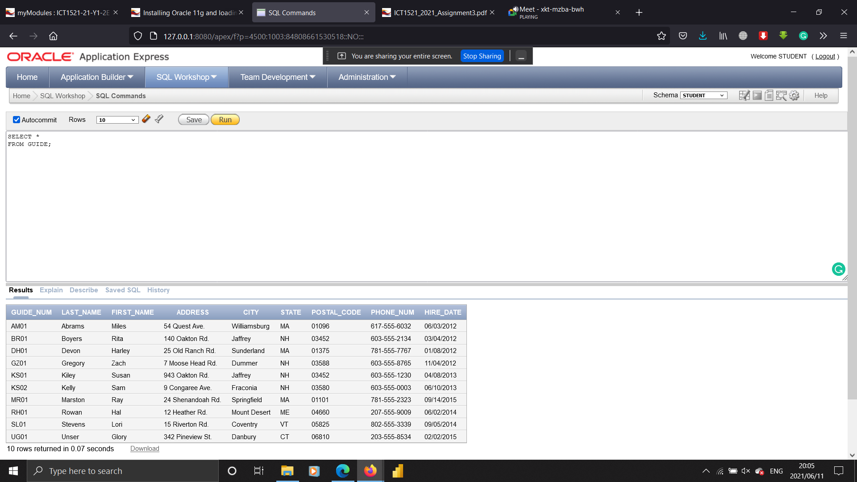1 . List the last name of each guide that does not live in Massachusetts (MA).

2. List the trip name of each trip that has the type Biking.

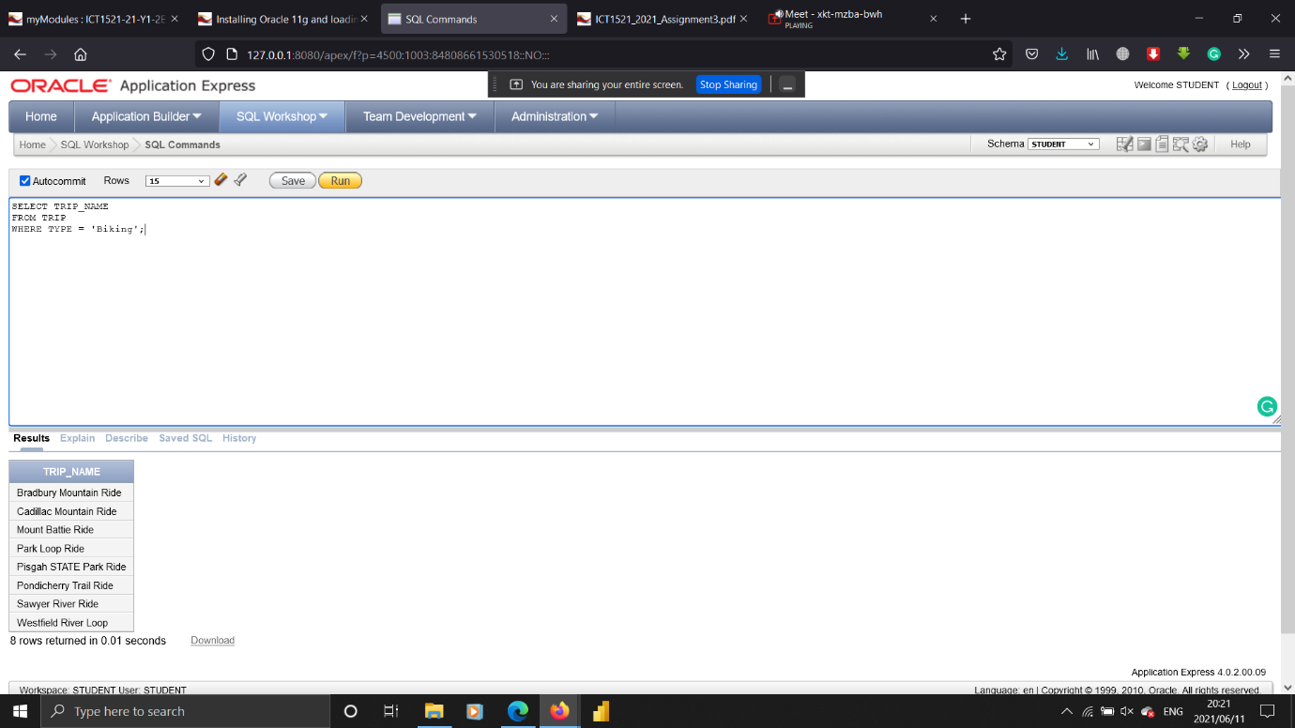

3 List the trip name of each trip that has the season Summer.

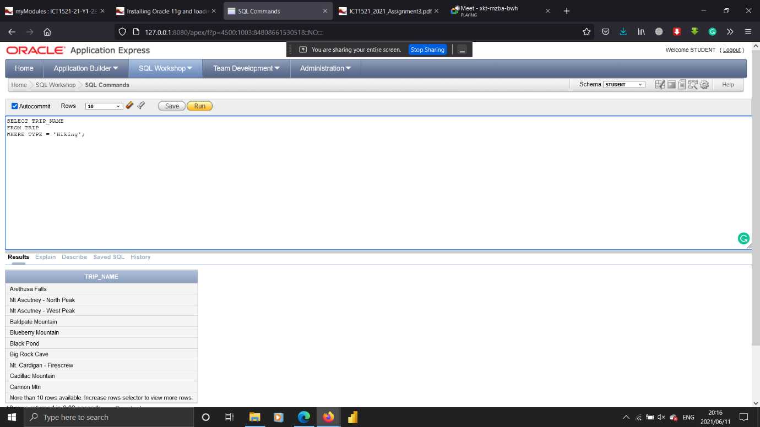

4 List the trip name of each trip that has the type Hiking and that has a distance longer than 10 miles.

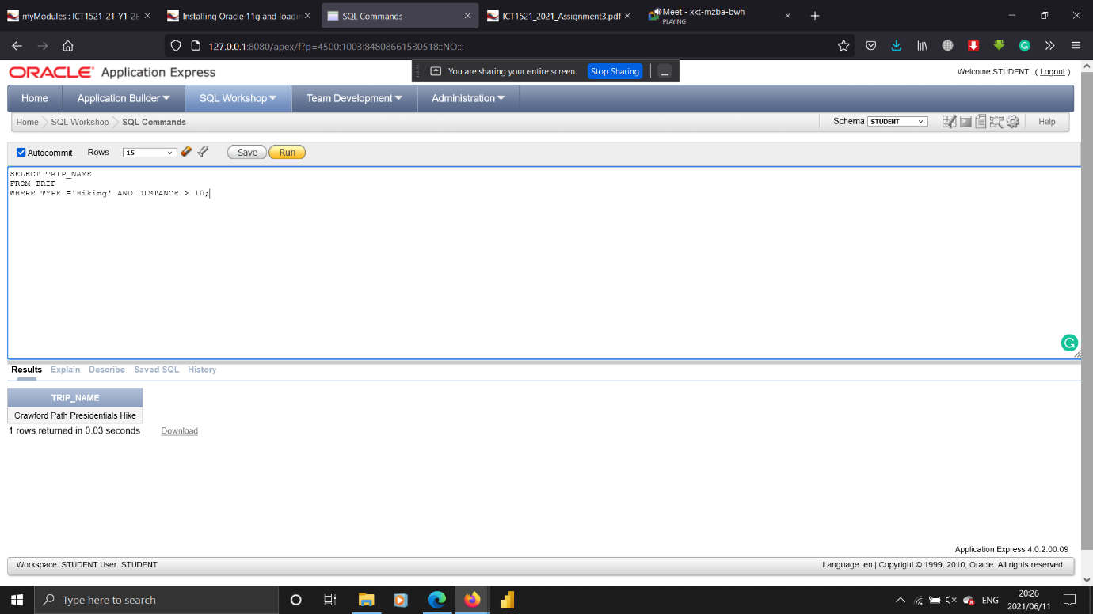

7 How many trips are in the states of Maine (ME) or Massachusetts (MA)?

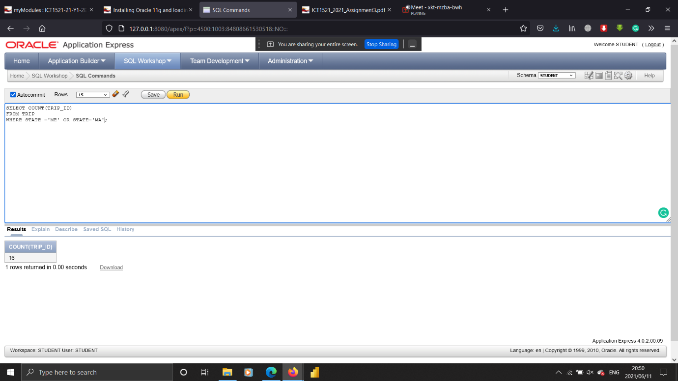

8 How many trips originate in each state?

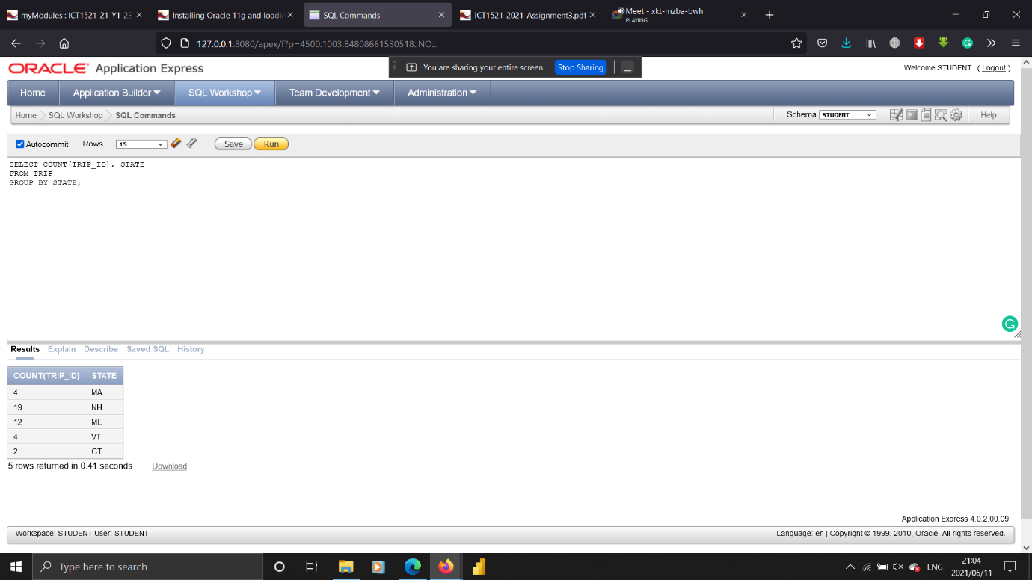

9 How many reservations include a trip price that is greater than $20 but less than $75?

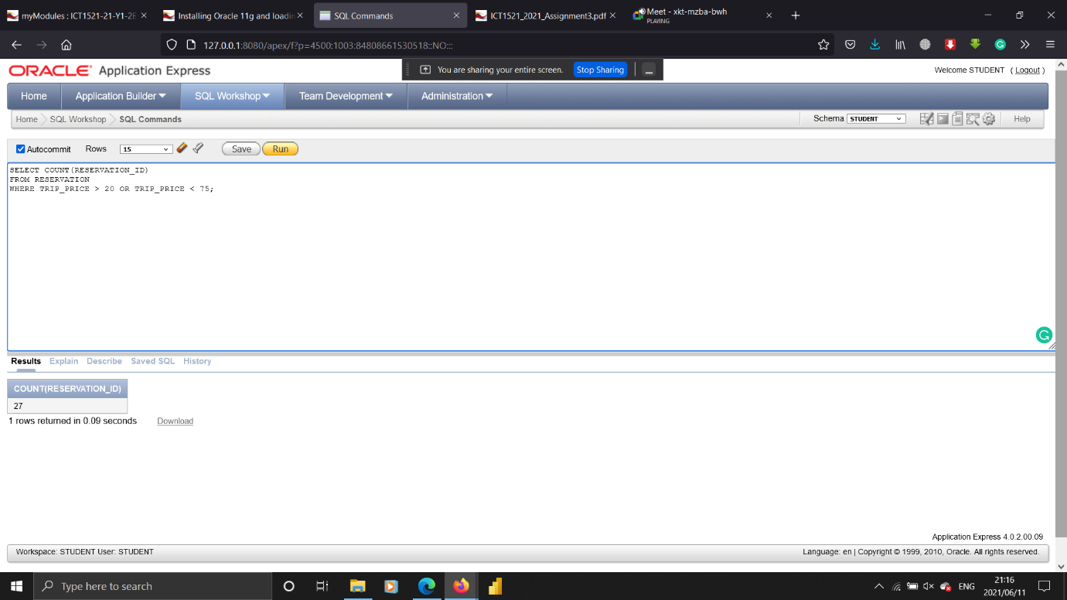

10 How many trips of each type are there?

